 

# PROPRIETARY INFORMATION

The information contained herein is proprietary to Airlinq Inc. Use or disclosure of this document or the information contained herein, for any purpose other than that for which it was furnished is not permitted or it shall not be disclosed or divulged to any third Party without the prior written consent of Airlinq Inc.

# COPYRIGHT NOTICE

This document is copyright © Airlinq Inc. All Rights Reserved. No part of this document, in whole or in part, may be used, reproduced, stored in a retrieval system or transmitted, in any form, or by any means, electronic or otherwise, including photocopying, reprinting, or recording, for any purpose, without the express written permission of Airlinq Inc.

# 

Contents

PROPRIETARY INFORMATION 1

COPYRIGHT NOTICE 1

Document Control 3

Version History 3

Review History 3

1. Introduction 4

I. Problem Definition 4

II. Purpose 4

III. Assumption and Dependencies 4

IV. Scope 4

V. Definitions and Abbreviations 5

VI. References 5

VII. Overview 5

2. Overall Description 6

I. Product Perspective 6

II. Product Functions 6

III. Design and Implementation Constraints 7

3. Design Description 8

I. Requirement Description 8

II. To-Be Scenario 20

a) Use Case Diagram: 20

b) Use Case Diagram: 21

# Document Control

## Version History

| **Version** | **Date** | **Description of Changes** | **Made by** |
| --- | --- | --- | --- |
| 0.1 | 2023-04-13 | As per Requirement | Team-02 |
| 0.2 | 2023-04-14 | Updated Figma and Documents | Team-02 |
| 0.3 | 2023-04-17 | Updated complete SRS | Team-02 |

[Date format is yyyy-mm-dd.]

## Review History

| **Version** | **Date** | **Reviewer** | **Signature** |
| --- | --- | --- | --- |
| 0.1 | 2023-04-13 | Abhishek Jain |  |
| 0.2 | 2023-04-14 | Abhishek Jain |  |
| 0.3 | 2023-04-17 | Abhishek Jain |  |

[Approval is Requirement for any project that may affect the financial control. If not Requirement, leave the table empty.]

# Introduction

The document clarifies the basic properties and programming necessities of the College Management System.

## Problem Definition

Manual learning framework has been utilized for a long time. However, in college, students want to learn extra courses but due to lack of resources and due to money problems students can't enrol into various online education platforms. To resolve these issues, there is a need for an online college management system, students can enroll into various online courses and increase their skills and knowledge.

## Purpose

The purpose for this document is to make the practical and non-practical prerequisites of the College Management System straightforward. It likewise effectively makes the usefulness clear to end clients.

The purpose of this document is to retrieve and analyse the ideas that define the product and requirements that the user needs. This document describes the details of our product, its parameter, and its goals. This SRS document describes the target, audience, user interface of the product and Software/Hardware requirements of our product. This document also describes the problem we have faced during the designing and implementation of the product and also describes how we have solved this problem and made our product more efficient. The management system saves the human power and time cost to perform the same task. The data in the database can be saved for a long time and can be used for different purposes in the future. In management systems, there is a minor chance of losing the data. This document also defines how customers and users see our product and understand the functionality of the product. This document will help the developers/designers in case of maintenance of the software product.

## Assumption and Dependencies

1. Each user must have Login_ID and Password for Login.
2. Internet Connection is a must.
3. Client/User runs an operating system which Supports Internet Browsing.
4. Proper browser must be installed.
5. The system should have more capacity and provide fast access to the database.
6. The system should be user friendly so that it is easy to use for the users.
7. The code should be error free.
8. The College Management System is running 24 hours a day.
9. The information of all users must be stored in a database that is accessible by the College management System.
10. On the basis of listing requirements and specification the project will be developed and run.
11. The College Management System provides a unique Login_ID to every user after registration.

## Scope

The SRS document applies to the preliminary version of the "College Management System" software package. This document portrays the demonstrating and necessity examination of the framework. The fundamental point of the framework is to give an arrangement of conventions that enables learners to learn courses remotely using the internet and learners can learn courses as much he want.

## Definitions and Abbreviations

The subsequent is a rundown of terms, acronyms and abbreviations used by the College Management System software package and related documentation.

| **CMS** | College Management System |
| --- | --- |
| **DBMS** | Database Management System. |
| **SQL** | Structured Query Language, used to create the database |
| **MySQL** | MySQL is a database management system in which database is created and manages the database like “update”, “Delete” and insert a new record in the database |
| **VS Code** | Visual Studio Code |

## References

* [**https://www.studocu.com/row/document/nahda-university/computer-science/srs-for-university-management-system/27752841**](https://www.studocu.com/row/document/nahda-university/computer-science/srs-for-university-management-system/27752841)
* [**https://t4tutorials.com/functional-requirements-of-the-college-management-system-project/**](https://t4tutorials.com/functional-requirements-of-the-college-management-system-project/)
* [**https://studfile.net/preview/9842169/**](https://studfile.net/preview/9842169/)
* [**https://www.youtube.com/watch?v=F6PWouOKDLA**](https://www.youtube.com/watch?v=F6PWouOKDLA)
* [**https://www.youtube.com/watch?v=y7iPJTQ9-_Y**](https://www.youtube.com/watch?v=y7iPJTQ9-_Y)

## Overview

The rest of this document categorizes the actors, use-cases, entity relationship diagram, data flow diagram, assumptions, and dependencies for the investigation and plan of the College Management System. The remaining document contains the general depiction of the framework, prerequisites, information and social portrayal of the framework.

# Overall Description

## Product Perspective

It is a replacement for the traditional teaching system where students have to learn courses by reaching college and by sitting in classrooms and note the important points and students have to solve assignments that are provided by the teacher physically.

## Product Functions

The target audience for CMS product is the college Administrator/students/staﬀ .

* Administrator: The Super user of the system. Mainly focuses on administrative and academic related issues.
* Admin should be able to add, manage and remove the users(student and teacher).
* Admin should be able to add, modify and delete users information(DOB, name, ID, password, login ID).
* Admin should be able to add, manage and delete courses.
* Admin can manage (add, modify and delete) videos, course documents and assignments in their created courses.
* Student: A user with limited access rights.
* Students can Register themselves using their Student Id.
* Students can Login into the system using their login credentials(Login Id, password and User Type).
* Students can see all courses available on CMS online application and enroll themselves into courses they want to enroll in.
* Students can see videos, see course documents and solve assignments of their enrolled courses.

* Staff: A user with limited access rights.
* Staff can Register themselves using their Staff Id.
* Staff can Login into the system using their login credentials(Login Id, password and User Type).
* Staff can add and modify courses on CMS online application and can maintain students enrolled in their courses.
* Staff can add videos, course documents and assignments in their created courses.
* Staff can manage students joined in their respective courses.

## Design and Implementation Constraints

* The user cannot change his/her Login ID.
* The Internet connection is also a constraint for the application. Since the application fetches data from the database over the Internet, it is crucial that there is an Internet connection for the application to function.
* The web portal will be constrained by the capacity of the database. Since the database may be forced to queue incoming requests and therefore increase the time it takes to fetch data.

# Design Description

## Requirement Description

* 1. Users can register him/herself in the system with his/her User_ID, Name, Email, User_Type and Password. After registration users can login using Login Credentials Login_ID, Password and User Type.

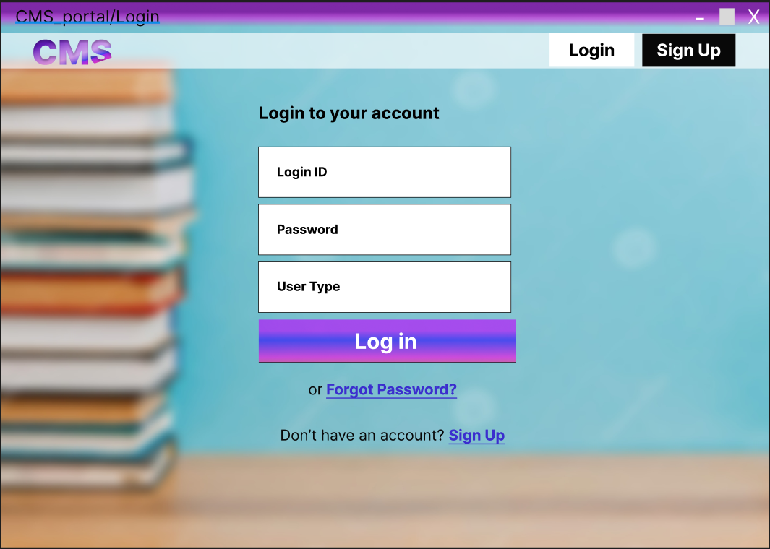

**Login Page**

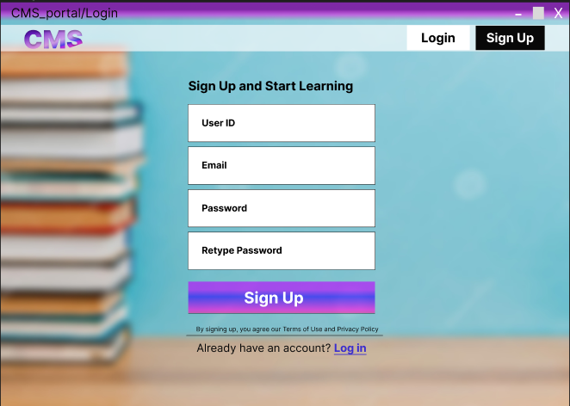

**Sign Up Page**

* 1. During registration System checks whether the user is belongs to college or not by verifying his details with college database and send OTP on his email for verification.

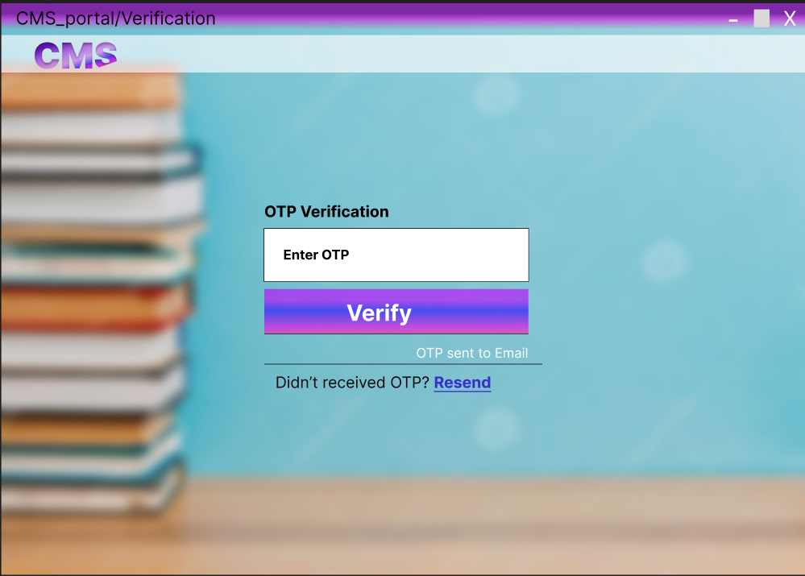

**Verification Page**

* 1. After Registration system provide unique Login_ID to every user

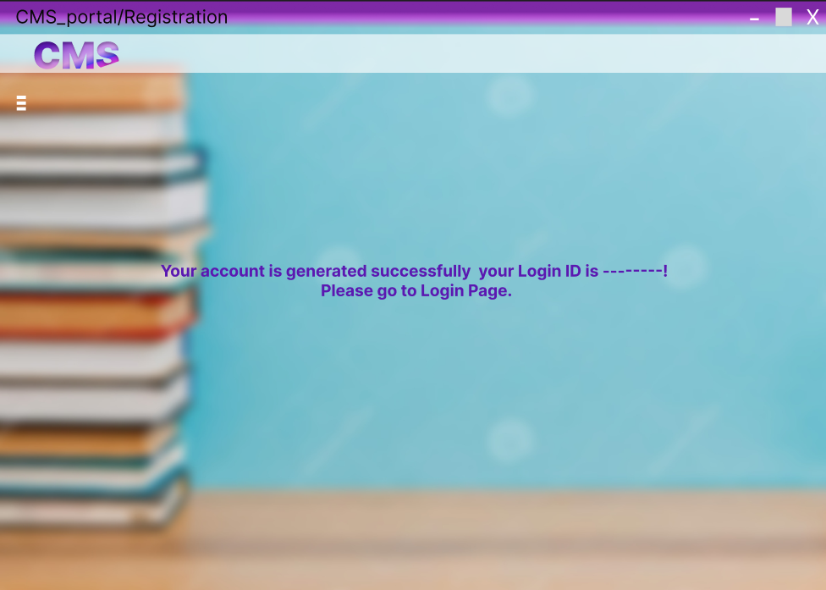

**Verification Page**

* 1. If user is Staff then he/she can see his dashboard, and add a new course, see created, course, Edit profile, change his/her login password and Raise a Query from his dashboard.

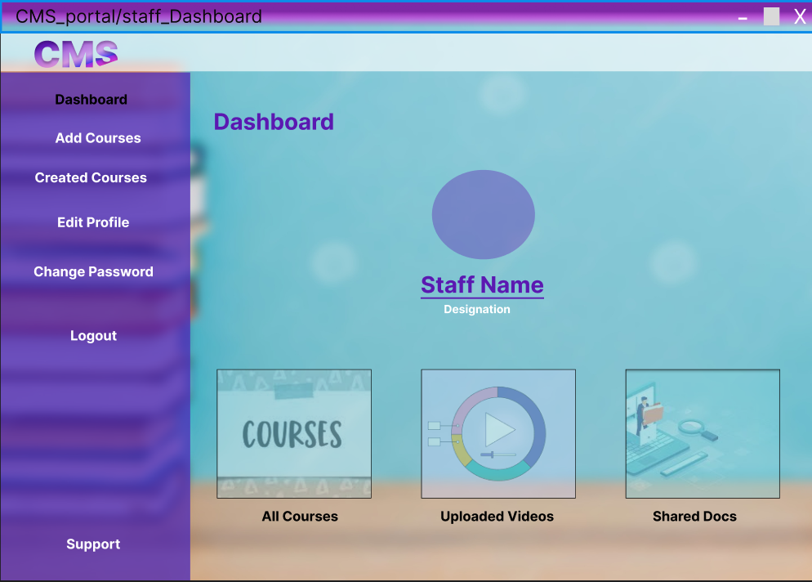

**Staff Dashboard**

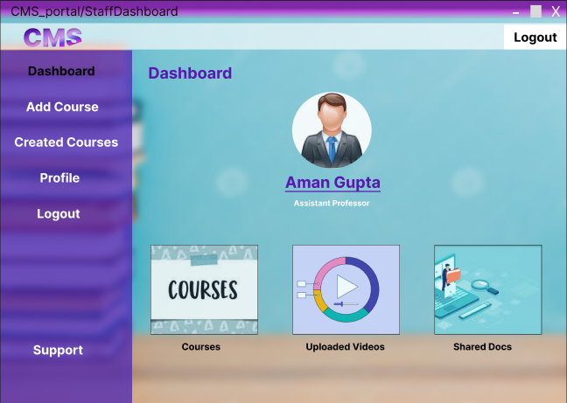

**Staff Dashboard**

* 1. On Courses page staff can see all courses and total number of students joined in the particular course.

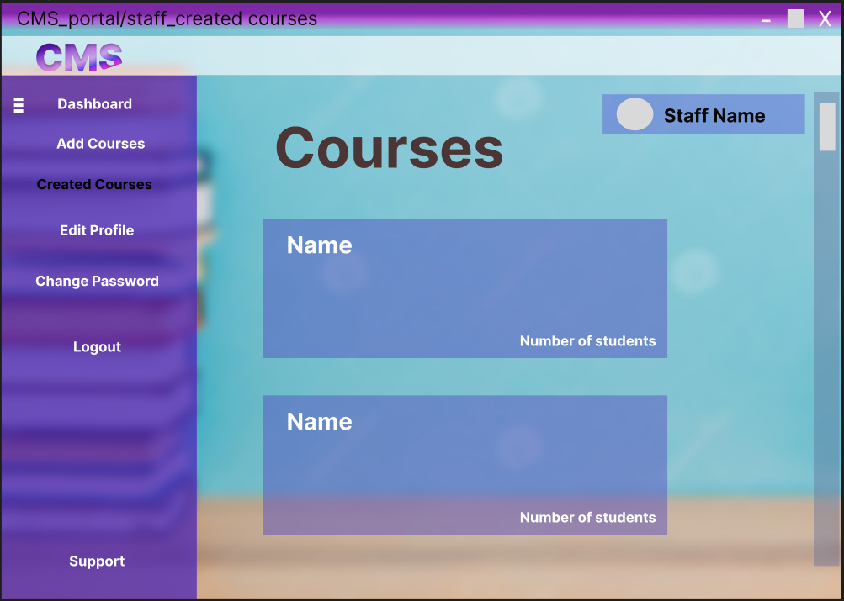

**Staff Created Courses**

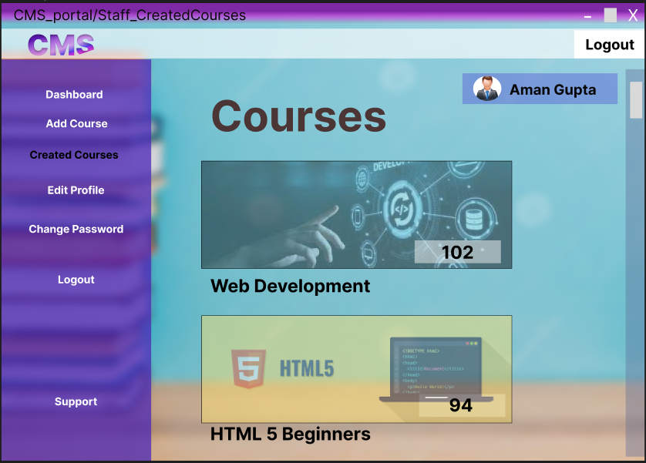

**Staff Created Courses**

* 1. When Staff open particular created course he can see Course Detail, list of Students who enrolled in course and see option to open videos, documents and assignments related to that course and see course related questions asked by students.

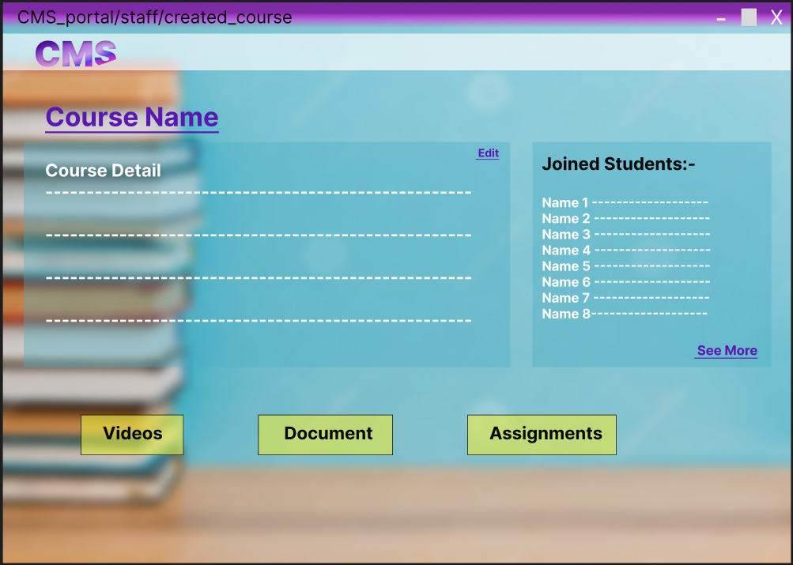

**Staff Created Course**

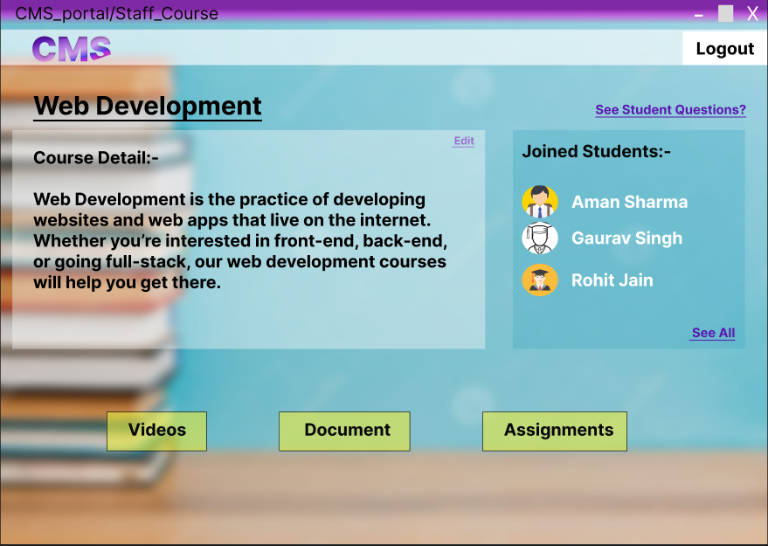

**Staff Created Course**

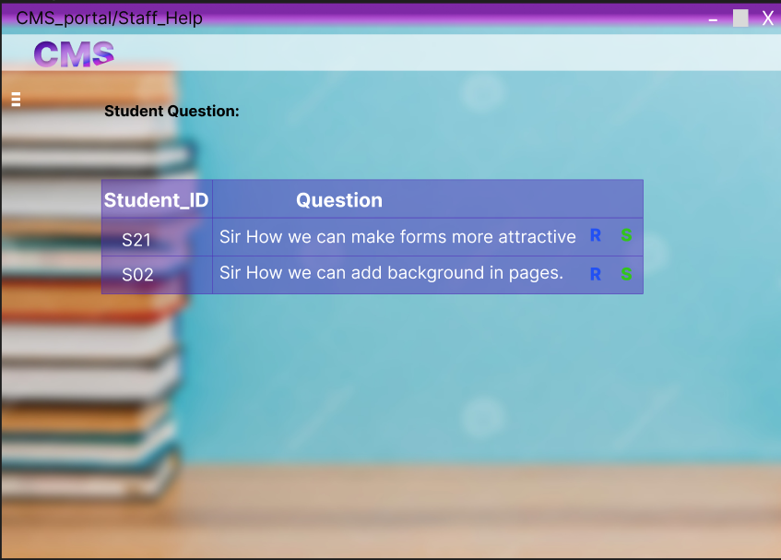

**See Students Course related Questions and perform some actions**

* 1. If the user is Student then he/she can see his dashboard, and see All Courses, see his joined courses, Edit profile, change his/her login password and Raise a Query from his dashboard.

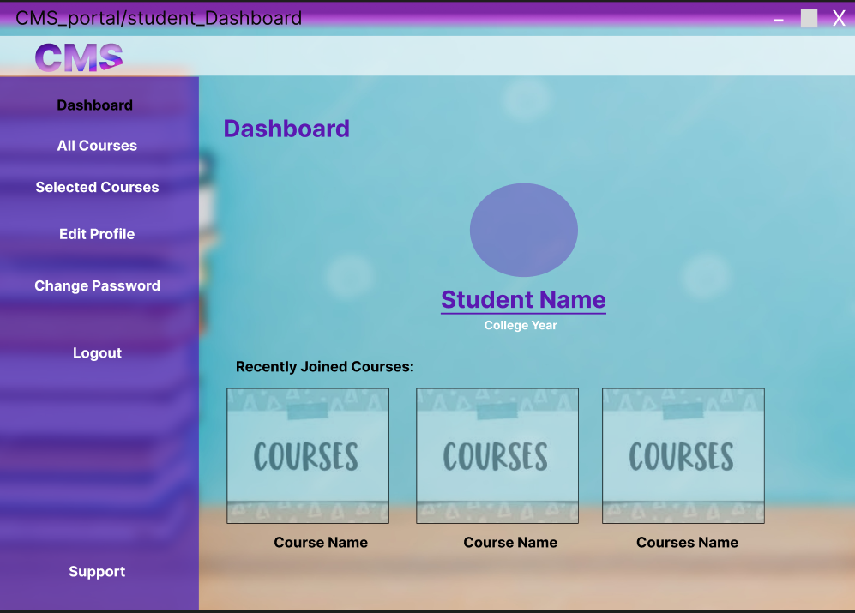

**Student Dashboard**

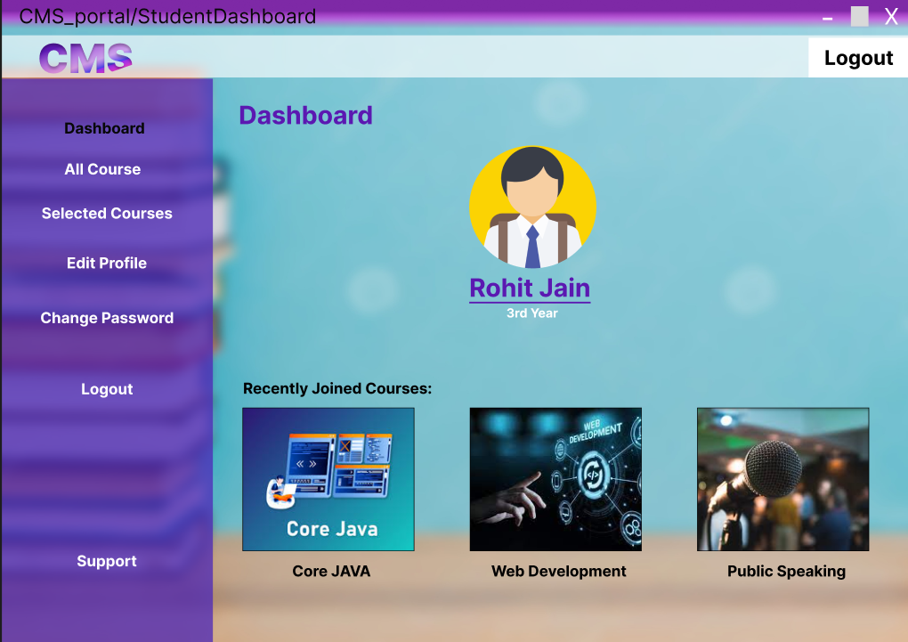

Student Dashboard

* 1. On All Courses page students can see all courses and can enrol in the particular course.

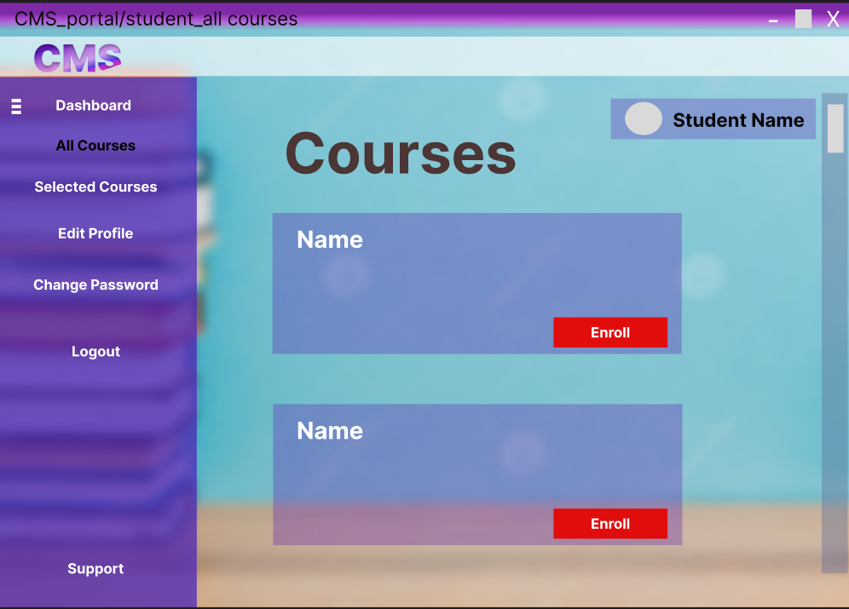

**Student All Courses Page**

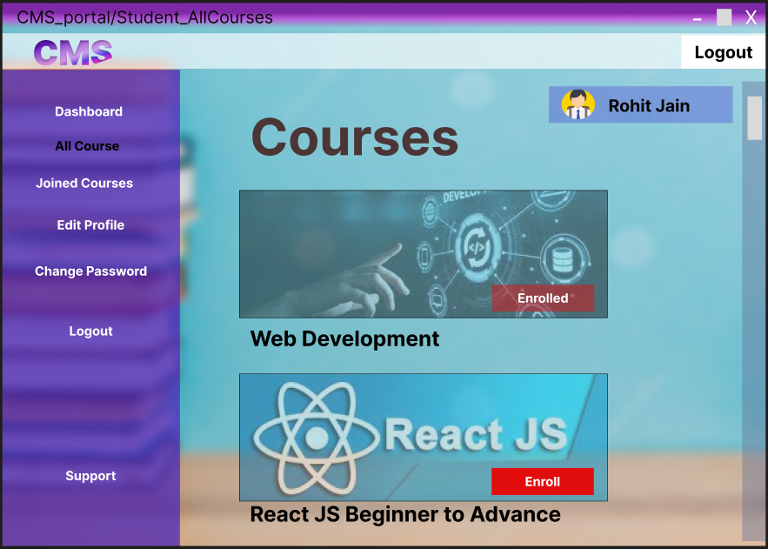

**Student All Courses Page**

* 1. At the course page student have option to see videos, documents, solve assignments and ask course related query from staff .

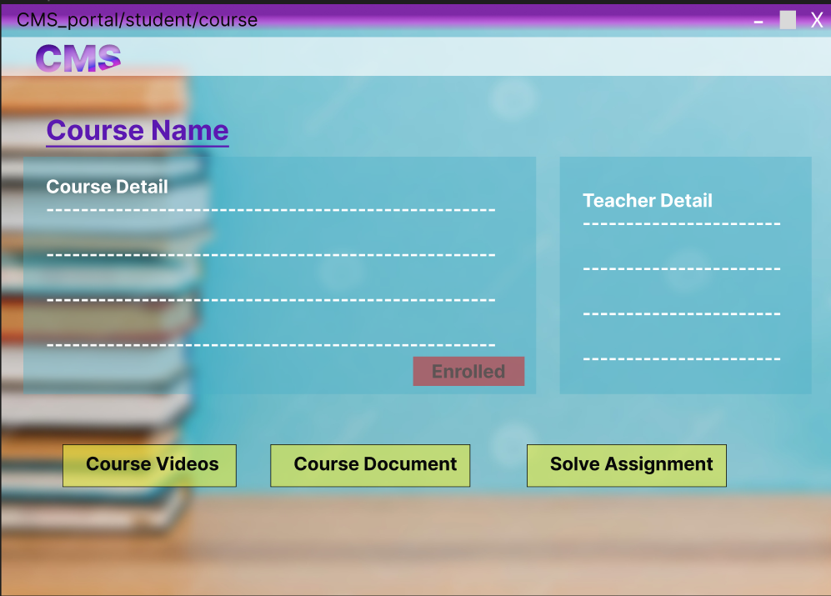

**Student Joined course page**

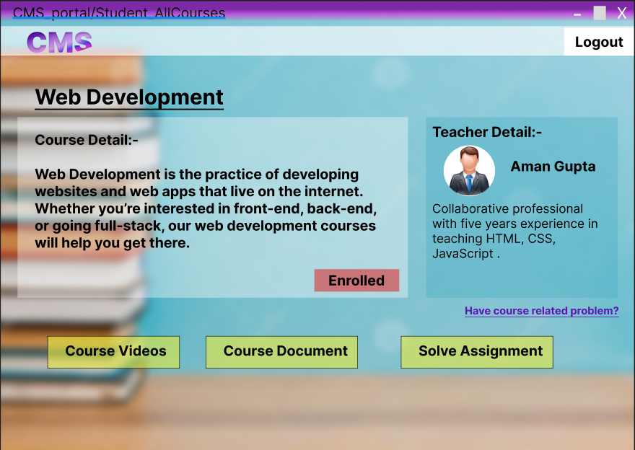

**Student Joined course page**

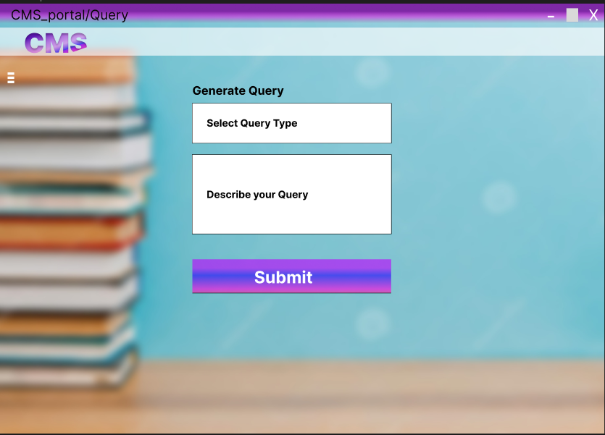

**Generate Query Page**

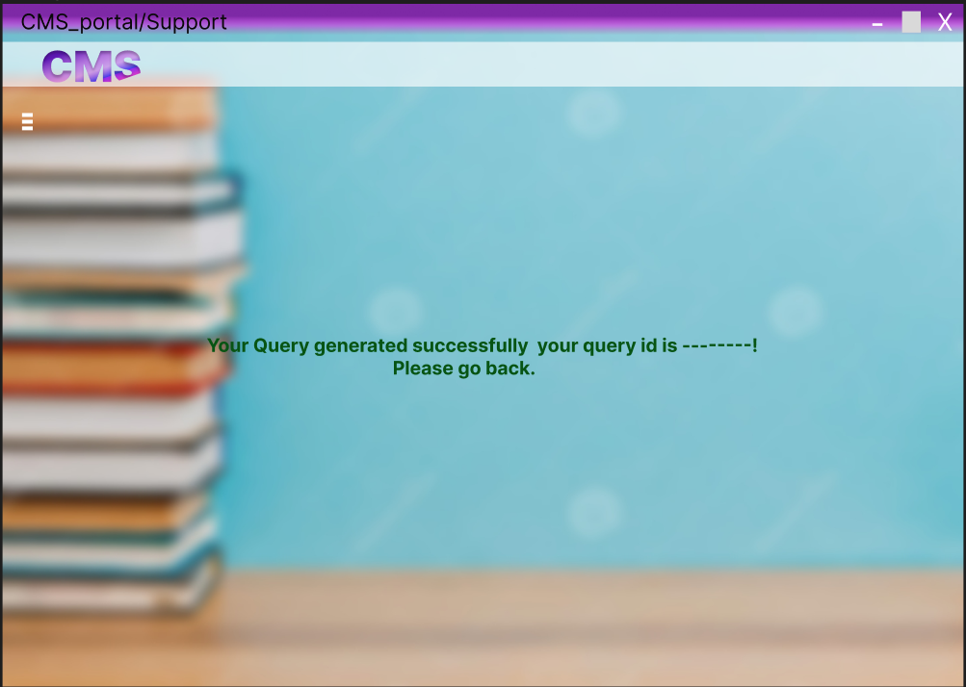

**Query Submitted Successfully**

* 1. If the user is Admin then he/she gets his/her Login_ID and Password from developer directly and can see his dashboard, and see All Staff, All Student, All Courses, and see all Raised a Query by clicking on links from his dashboard.

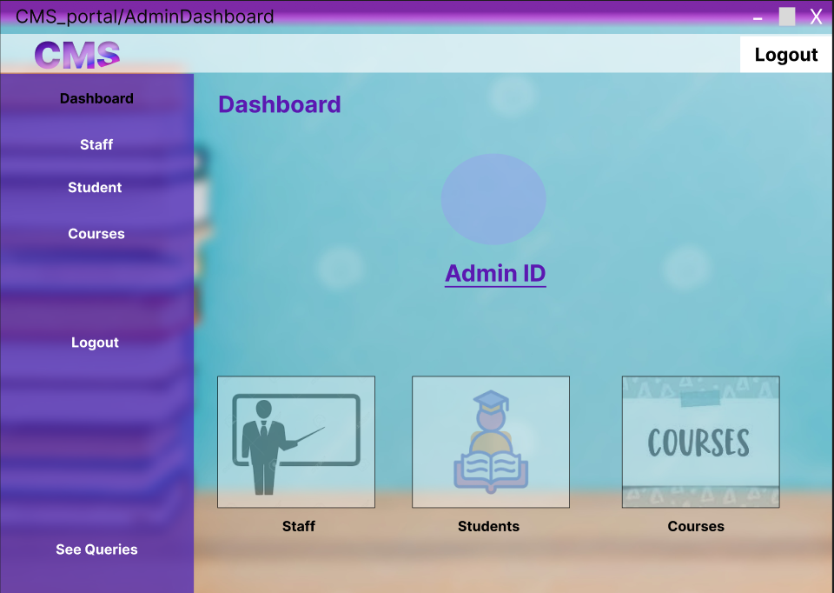

**Admin Dashboard Page**

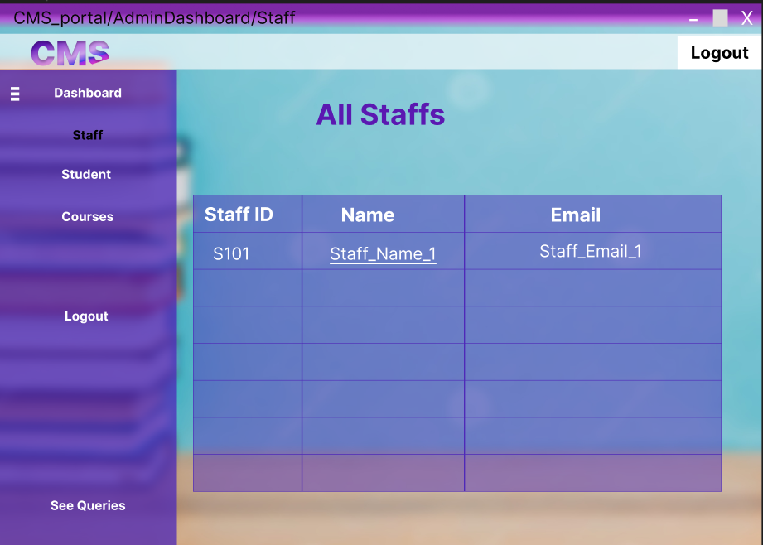

**Staff Page**

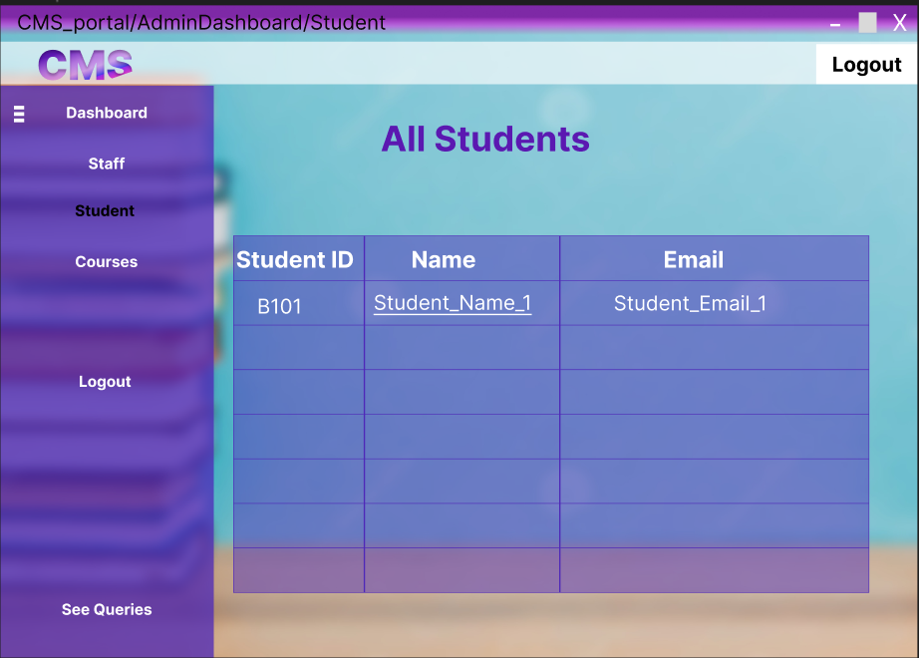

**Admin Student Page**

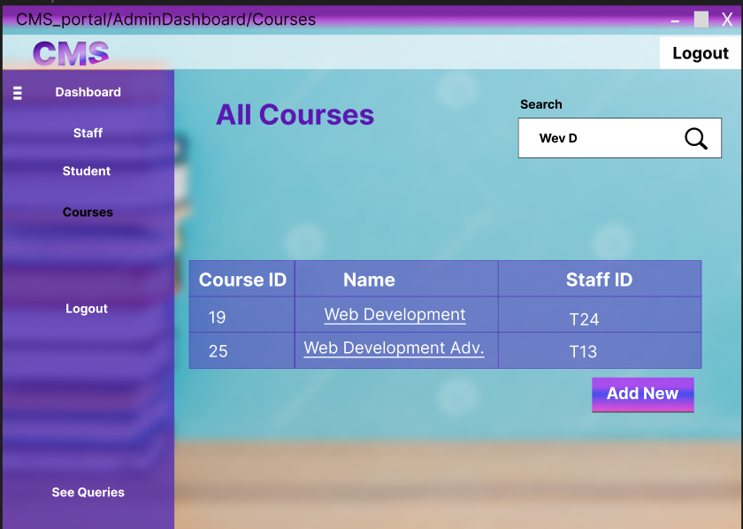

**Admin Courses Page**

* 1. On queries page admin can see all queries of users by selecting Query_Type and respond to them.

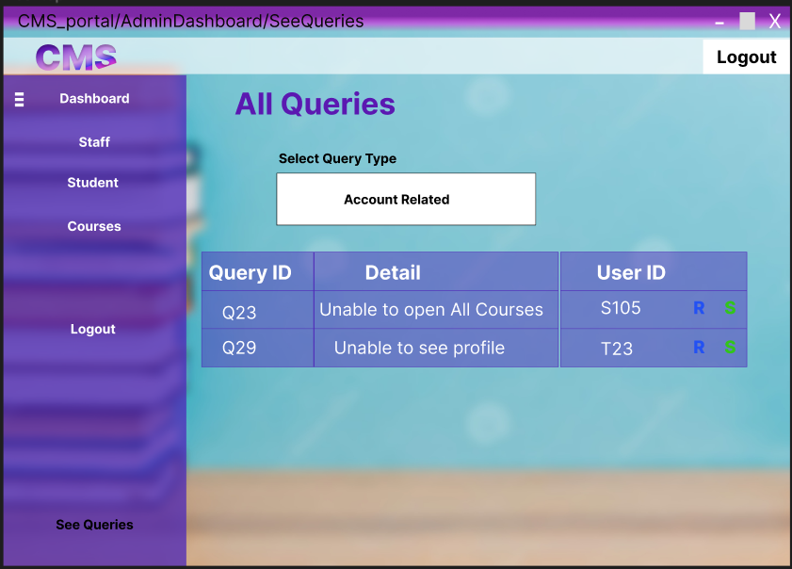

**See Queries Page**

## To-Be Scenario

All the Requirements described in Section 3.1 will be implemented on the College Management System after the deployment of Current Requirement.

# Use Case Diagram:

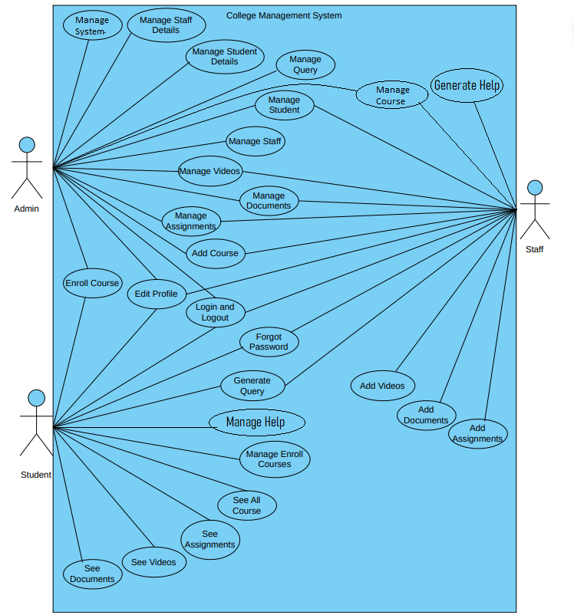

**Use-Case Diagram**

# Use Case Diagram:

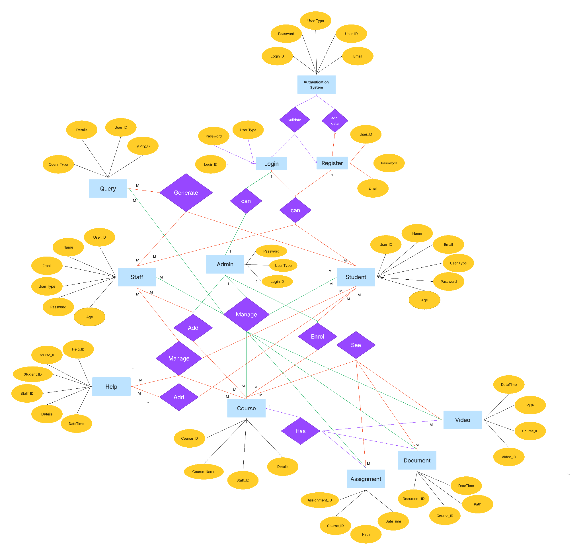

**ER Diagram**

